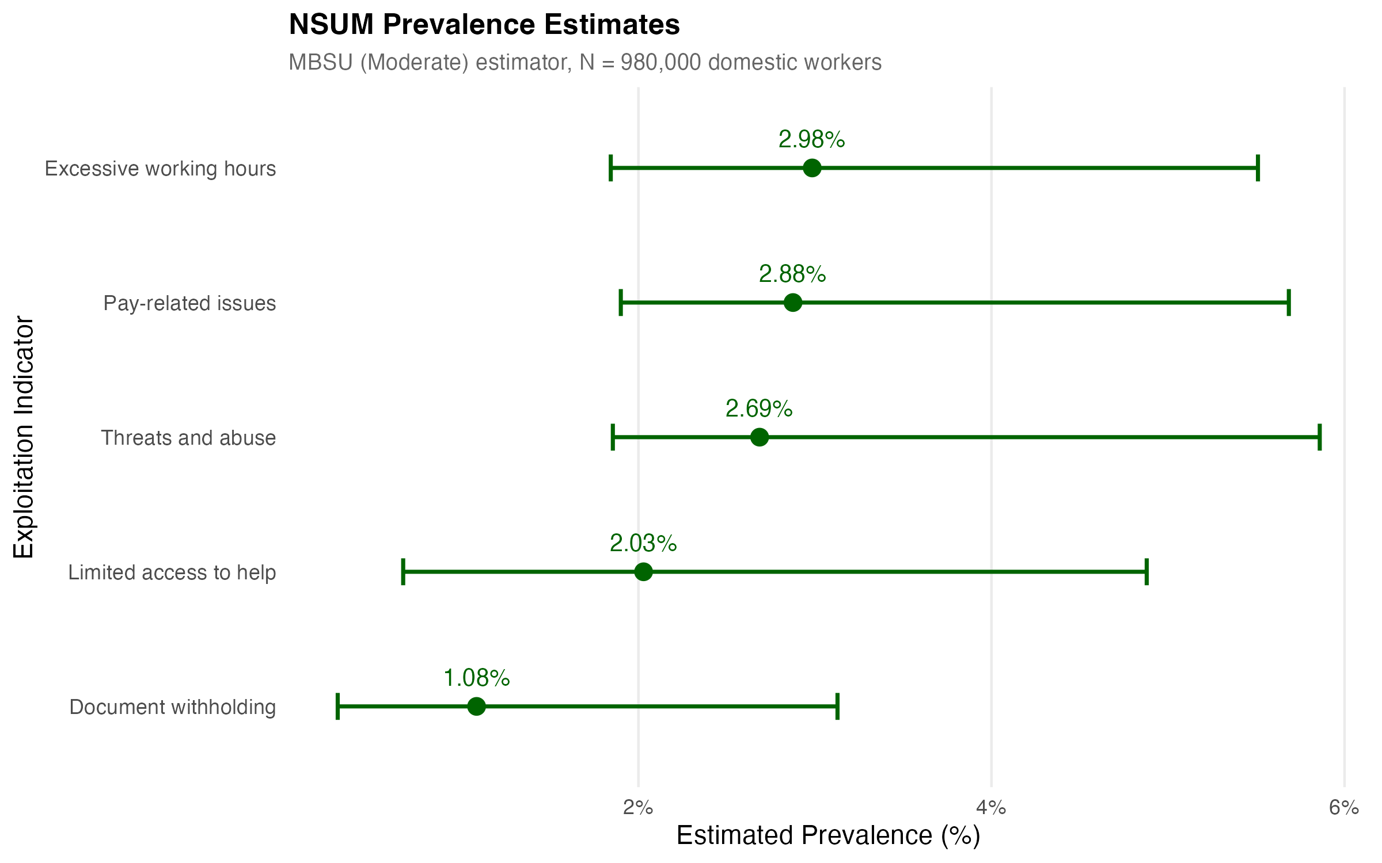
Figure 5. NSUM Prevalence Estimates. Modified Basic Scale-Up (MBSU, Moderate adjustment) estimator with neighbourhood-bootstrap 95% confidence intervals for the five binary exploitation indicators at N=980,000 domestic workers. Source: Authors' own work.

